**SCHOOLITE**

#### A

**MAJOR PROJECT REPORT**

*Submitted in partial fulfillment of the requirements for the award of the degree of*

#### BACHALOR OF TECHNOLOGY

In

**Computer Science & Engineering Submitted to**

#### RAJIV GANDHI PROUDYOGIKI VISHWAVIDYALAYA,

**BHOPAL** (M.P.)



### Department of Computer Science Engineering Sri Aurobindo Institute of Technology, Indore (M.P.)

**2023-2024**

#### SCHOOLITE



*The Major Project-I report submitted to*

*Rajiv Gandhi Proudyogiki Vishwavidyalaya, Bhopal towards partial fulfillment of the Degree of*

*Bachelor of Technology in*

*Computer Science & Engineering*

##### Guided by Submitted by

Sudha Sharma Sharddha Shaiv

Assistant Proffessor Himanshu Sharma

### Department of Computer Science Engineering Sri Aurobindo Institute of Technology,Indore(M.P.)

**2023-2024**



**RECOMMENDATION**

This is to certify that Miss Shraddha Shaiv(0873CS201092), Mr. Himanshu Sharma(0873CS201036), student of B.Tech. VII Semester in the year 2023-24 of Computer Science Engineering Department of this institute has completed his/her/their work on “***SCHOOLITE***” for Major Project-I based on syllabus and has submitted a satisfactory account of his/her/their work in this report which is recommended for the partial fulfillment of the degree of Bachelor of Engineering in Computer Science.

**Project Guide, HOD,**

**Sudha Sharma Sunil Parihar**

CSE Department CSE Department

SAIT Indore SAIT Indore

**Director, SAIT Indore**



**CERTIFICATE**

This is to certify that the work embodied in this project entitled “***Schoolite***” being submitted by Miss Shraddha Shaiv(0873CS201092), Mr. Himanshu Sharma(0873CS201036), student of B.Tech. VII semester, Computer Science Engineering department in the year 2023-24, is a satisfactory account of his/her/their work based on syllabus which is accepted in partial fulfillment of degree of Bachelor of Engineering in Computer Science .

###### INTERNAL EXAMINER EXTERNAL EXAMINER

**Date Date**



**DECLARATION**

We hereby declare that the Project entitled **“Schoolite"** is our own work conducted under the supervision of **Sudha Sharma**, Designation, Department of Computer Science & Engineering at **Sri Aurobindo Institute of Technology, Indore, M.P.**

We further declare that to the best of our knowledge this report does not contain any part of work that has been submitted for the award of any degree either in this institute or in other institute without proper citation.

Shraddha Shaiv 0873CS201092 Himanshu Sharma 0873CS201036

**ACKNOWLEDGEMENT**

We express deep gratitude for enthusiasm and valuable suggestions that we got from our guide **Ms.SUDHA SHARMA** for successful completion of the project. This project was not possible without the invaluable guidance of our project guide.

We are also thankful to our project coordinator **Ms.Sudha Sharma,** for his/her technical guidance, encouragement and support.

We are deeply indebted to **Mr.Sunil Parihar**, Head Department of Computer Science and Engineering, for providing us support and resources for successful completion of this project.

I would like to give thanks to **Mr. Amit Holkar** , Head Academics for their valuable guidance and motivation for the completion of the work.

Finally, we are thankful to all the people who are related to the project directly or indirectly.

Shraddha Shaiv 0873CS201092 Himanshu Sharma 0873CS201036

#### REPORT FORMAT

**CS-VII SEMESTER JUL-DEC 2023**

###### FRONT PAGE

###### RECOMMENDATION II

###### CERTIFICATE III

###### DECLARATION IV

###### ACKNOWLEDGEMENT V

###### ABSTRACT VI

###### TABLE OF CONTENTS VII

###### TABLE INDEX VIII

###### FIGURE INDEX IX

**List of Symbols, Abbreviations and Nomenclature X**

1. **INTRODUCTION**
   1. **Introduction to current system**
   2. **Need of *proposed* system**
   3. **Objectives**

###### SYSTEM DEVELOPMENT LIFE CYCLE

1. **ANALYSIS**
   1. **Requirement analysis**
   2. **Requirement Specification**
   3. **Usecase Analysis**
      1. **Usecase diagram**
      2. **Usecase description**
      3. **Activity diagram**

###### DESIGN

* 1. **System Flow Diagram**
  2. **Data Flow Diagram**
  3. **Modules identified**
  4. **Sequence Diagrams**
  5. **Class Diagram**
     1. **Database Design**

1. **E-R Diagram**

###### IMPLEMENTATION

* 1. **Platform Used**
     1. **Hardware Platform**
     2. **Software Platform**
  2. **Implementation Level Details**
  3. **Testing**
     1. ***Testing Technique* used**

###### CONCLUSION

* 1. **Important Features**
  2. **Limitation**
  3. **Future Work**

1. **REFERENCES**

# CHAPTER – 1 INTRODUCTION

##### Introduction to current system

This project is a actually a web based school student requirement shop for their school & education related needs. In this website we have our city top-10 school list in which provide their uniform , syllabus kit , stationery , worksheet or any other requirement related to this schools.

This project is an attempt to provide the advantages of shop all the student need material related to this schools or any other education related benefits . It helps buying the products in the shop using internet . Thus the customer will

get the service of online shopping and home delivery .

##### Need of proposed system

The objective of the project is to make website to purchase items related to school. In order to build such an website that support any browser need to be provided. complete and efficient web which can provide the online student material shopping experience is the basic objective of the project.

##### Scope

In the scope , we can say that it can be expand from top-10 city level school to all over city level . 1 more scope is that further colleges can also be added in the future.so that in this expansion providing facilities can also be increased .

##### Problem in existing system

The current system for student uniform shopping is to visit the shop manually and from the available product choose the item customer want and buying the item by payment of the price of the item .

* It is less user-friendly.
* User must go to shop and select products.
* It is difficult to identify the required product. Description of the product limited.
* It is a time-consuming process Not in reach of distant users.

##### Statement of Problem

In the proposed system customer need not go to the shop for buying the products. The can order the product he wish to buy through the his Smartphone or any other devices . The system also recommends a home delivery system for the purchased products.

**CHAPTER - 2**

* + **SYSTEM DEVELOPMENT LIFE**

**CYCLE**

### Model Used

##### Agile

Agile is the chosen System Development Life Cycle (SDLC) model for the SCHOOLITE project. Agile emphasizes an iterative and flexible approach to software development. It allows for the incremental development of the project, enabling quick adaptation to changing requirements and priorities. The development process is broken down into smaller, manageable iterations, typically referred to as sprints, each lasting a few weeks.

##### Key Features of Agile:

**Iterative Development:** The project is divided into small, functional increments that are developed and tested in short cycles, ensuring early delivery of value to users.

**Adaptability:** Agile embraces change and allows for modifications in the requirements, features, and functionalities even late in the development process.

**Customer-Centric:** Regular customer feedback is integrated into the development process, ensuring the final product meets the users' needs effectively.

**Cross-Functional Teams:** Collaborative, multi-disciplinary teams work together in a flexible and interactive manner, fostering efficient communication and collaboration.

**Continuous Integration and Testing:** Code is frequently integrated and tested to maintain a high level of product quality throughout the development process.

Feel free to customize and add more details based on the specifics of your project and the level of depth you want to provide in the presentation

# CHAPTER -3 ANALYSIS

## SOFTWARE REQUIREMENT –

Supports any search engine or browser like google chrome , Microsoft edge , firefox etc.

#### IMPLEMENTTION REQUIREMENT – SOFTWARE PLATEFORM –

* + - **Web Development**: For the web-based platform, using technologies such as HTML, CSS, JavaScript for front-end development.
    - **Backend Development**: Consider using language Node.js for server-side scripting. Framework Express.js can help in creating robust and scalable back-end systems.

##### Database Management: -

Database technology MongoDB could be used for storing and managing data efficiently

## USER

#### USER LOGIN

##### Description of feature

This feature used by the user to login into system. user must login with his user name and password to the system after registration. If they are invalid, the user not allowed to enter the system.

##### Functional requirement

* + - * Username and password will be provided after user registration is confirmed.
      * Password should be hidden from others while typing it in the field

## REGISTER NEW USER

##### Description of feature

new user will have to register in the system by providing essential details in order to view the products in system. The admin must accept a new user by unblocking him.

##### Functional requirement

System must be able to verify and validate information.

The system must encrypt the password of the customer to provide security.

## PURCHASING ITEM

##### Description of feature

The user can add the desired product into his cart by clicking add to cart option on the product. They can view his cart by clicking on the cart button. All products added by cart can be viewed in the cart. User can remove an item from the cart by clicking remove. After confirming the items in the cart the user can submit the cart by providing a delivery address. On successful submitting the cart will become empty.

##### Functional requirement

System must ensure that, only a registered customer can purchase items.

## USE CASE –

The document mentions "USE CASE," which likely refers to a Use Case Diagram.

A Use Case Diagram is a visual representation of the interactions between actors (users or external entities) and the system.

It illustrates the various use cases or scenarios in which the system is used and the interactions between the actors and the system.

## USE CASE:

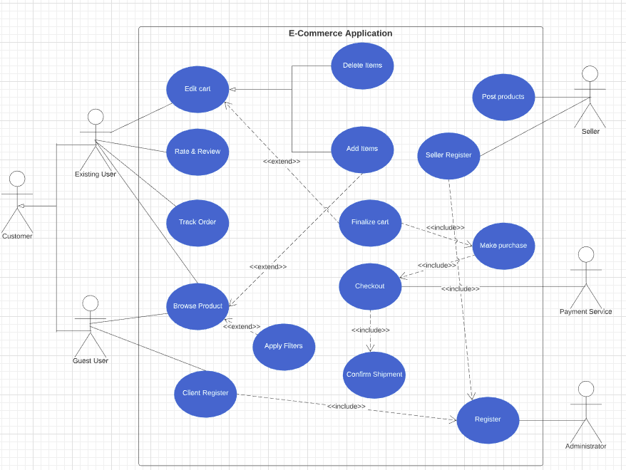

### Activity Dia -

The document refers to "Activity Dia," which likely refers to an Activity Diagram.

An Activity Diagram is a visual representation of the workflow or sequence of activities within a system or process.

It shows the flow of actions, decisions, and control flow between different activities or states.

**Activity Dia:**

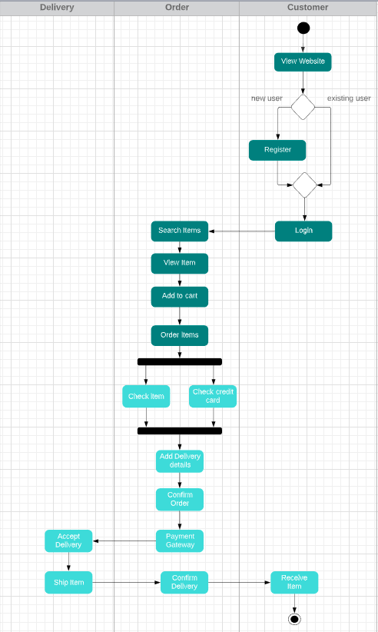

# CHAPTER – 4 DESIGN

### SYSTEM Dia –

The document does not provide specific information about the "SYSTEM Dia," so it's unclear what type of diagram it refers to.

**SYSTEM Dia:**

|  |
| --- |
| Web Based Platform |
| User Interface (UI)  Home Page Product Catalog  User log Shopping Cart Order History CheckDate  User Profile ………………. |
| Functionalities  Product Selection User Account and Filtering Management  Online Order Payment Processing and Placement Integration  Home Delivery Data Storage  Management and Retrieval |
| Backend  Node.js Server Mongo DB  Environment DataBase |

## DATA FLOW DIAGRAM

##### Data Flow Diagram (DFD):

A Data Flow Diagram is a graphical representation of the flow of data within a system.

It illustrates how data is input, processed, and outputted in a system, along with the various external entities that interact with the system.

The document mentions different levels of DFDs, including the context level (0 level) and specific levels for the admin side and user side.1st Level Admin Side DFD

**Context level DFD – 0 level**

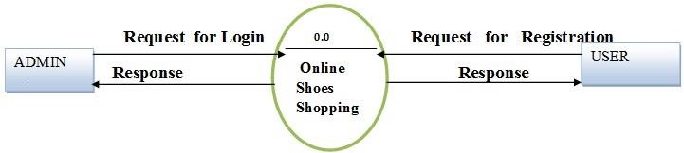

### Context Level DFD - 0 Level:

This refers to the highest-level DFD that provides an overview of the entire system.

It shows the system as a single process or function and the external entities that interact with it.

### 1st Level Admin Side DFD:

This diagram represents the data flow within the administrative side of the system at the first level of detail.It provides a more detailed view of how data is processed and flows within the administrative functions of the system.

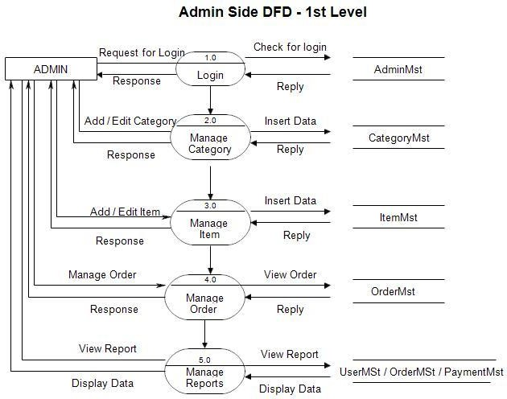

### 2nd Level – Admin side DFD

This diagram represents a further breakdown of the data flow within the administrative side of the system at a second level of detail.

It provides a more granular view of the data flow and processes specific to the administrative functions.

**2nd Level - Admin Side DFD:**

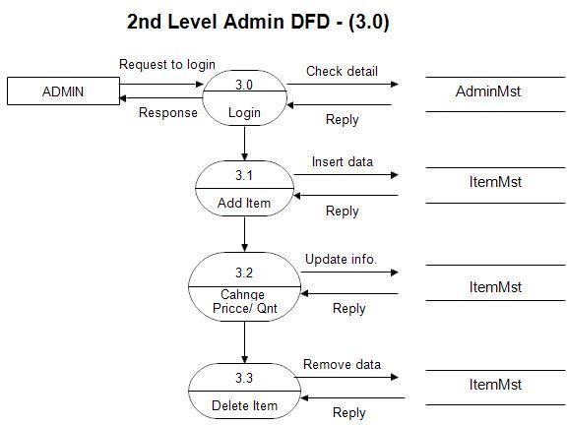

### 1st level – User side Data flow Diagram

This diagram represents the data flow within the user side of the system at the first level of detail.

It shows how data is inputted, processed, and outputted from the user's perspective.

**1st Level - User Side Data Flow Diagram:**

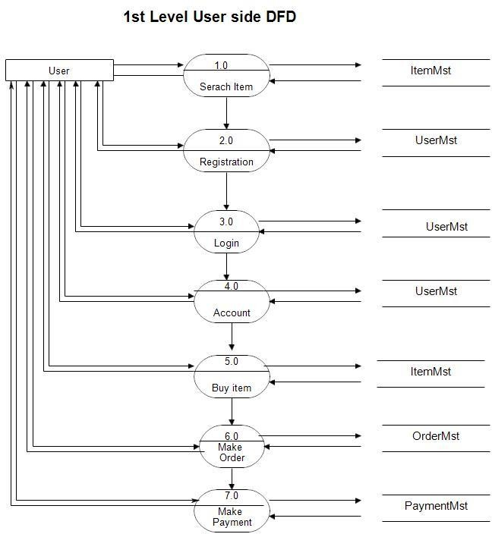

### 2nd Level - User Side DFD:

This diagram represents a more detailed view of the data flow within the user side of the system at a second level of detail.

It provides a closer look at the data flow and processes specific to the user's interactions with the system.

**2nd level – User side DFD**

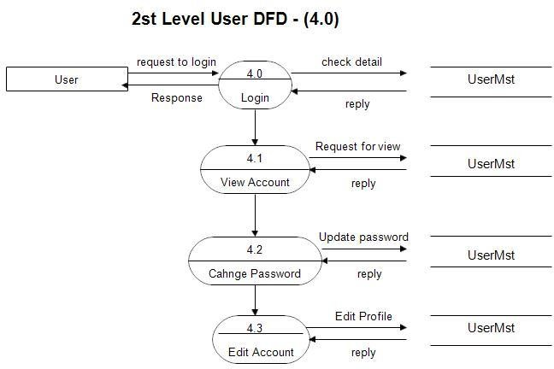

## SEQUENCE DIAGRAM –

**ADMIN**

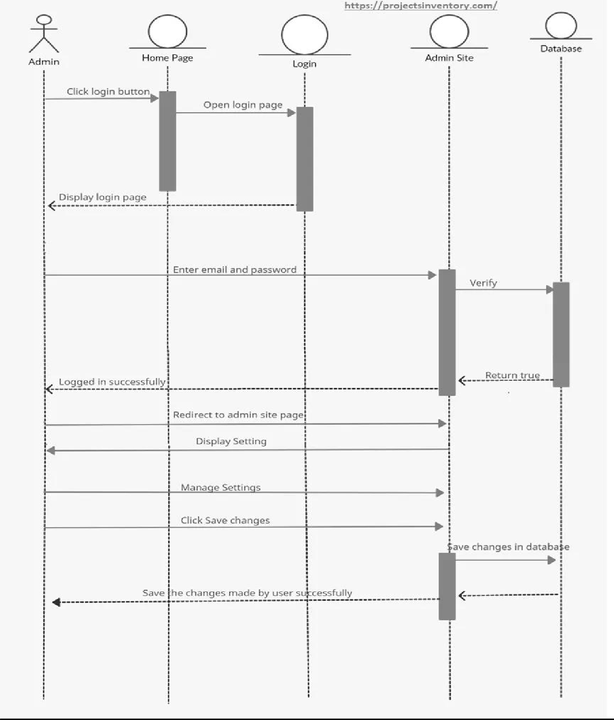

**USER**

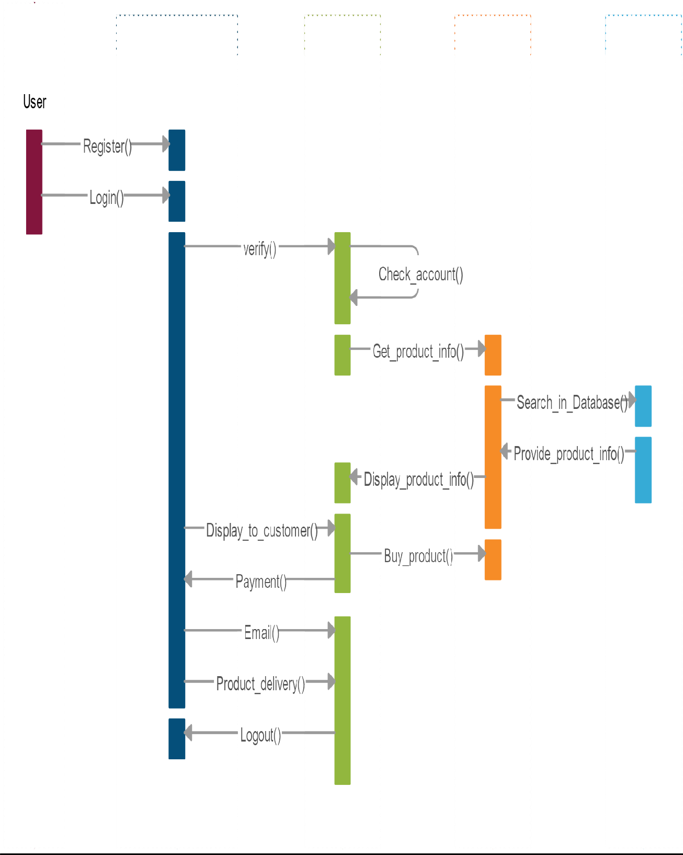

### Class diagram –

The document mentions "Class diag," which likely refers to a Class Diagram.

A Class Diagram is a visual representation of the classes, attributes, methods, and relationships within an object-oriented system.

**Class diagram:**

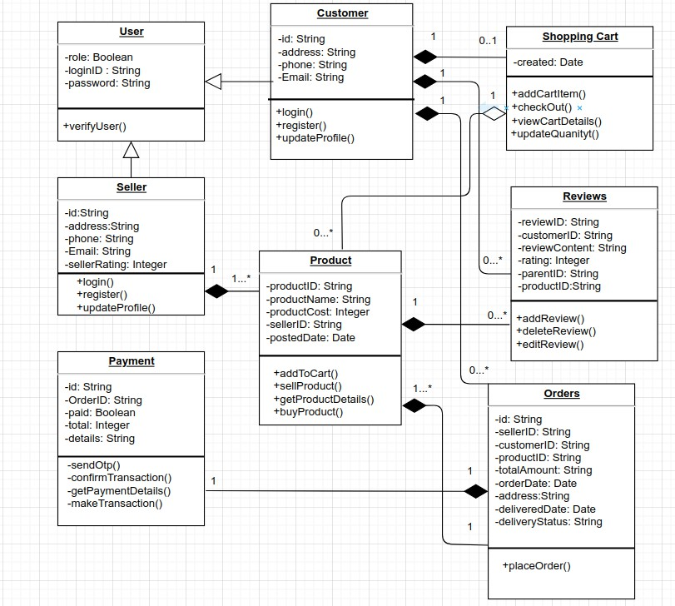

# CHAPTER - 5 E-R DIAGRAM

## E-R DIAGRAMS

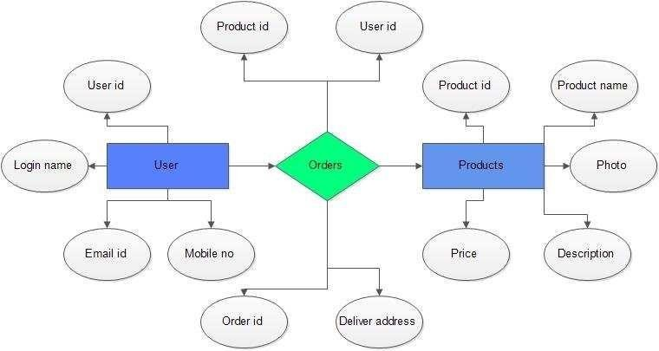

### E-R Diagrams (Entity-Relationship Diagrams):

* An E-R diagram is a visual representation of the entities (objects or concepts) and their relationships in a database system.
* It shows how different entities are related to each other through various types of relationships such as one-to-one, one-to-many, or many-to-many.

# CHAPTER - 6 IMPLEMENTATION

## SOFTWARE REQUIREMENT –

Supports any search engine or browser like google chrome , Microsoft edge , firefox etc.

#### IMPLEMENTTION REQUIREMENT – SOFTWARE PLATEFORM –

* + **Web Development**: For the web-based platform, using technologies such as HTML, CSS, JavaScript for front-end development.
  + **Backend Development**: Consider using language Node.js for server-side scripting. Framework Express.js can help in creating robust and scalable back-end systems.

##### Database Management: -

Database technology MongoDB could be used for storing and managing data efficiently

## USER

#### USER LOGIN

##### Description of feature

This feature used by the user to login into system. user must login with his user name and password to the system after registration. If they are invalid, the user not allowed to enter the system.

##### Functional requirement

* Username and password will be provided after user registration is confirmed.
* Password should be hidden from others while typing it in the field

## REGISTER NEW USER

##### Description of feature

new user will have to register in the system by providing essential details in order to view the products in the system. The admin must accept a new user by unblocking him.

##### Functional requirement

System must be able to verify and validate information.

The system must encrypt the password of the customer to provide security.

#### PURCHASING ITEM

##### Description of feature

The user can add the desired product into his cart by clicking add to cart option on the product. They can view his cart by clicking on the cart button. All products added by cart can be viewed in the cart. User can remove an item from the cart by clicking remove. After confirming the items in the cart the user can submit the cart by providing a delivery address. On successful submitting the cart will become empty.

##### Functional requirement

System must ensure that, only a registered customer can purchase items.

# CHATPER – 7 CONCLUSION

* The project entitled **Schoolite** was completed successfully.
* The system has been developed with much care and free of errors and at the same time it is efficient and less time consuming. The purpose of this project was to develop a web-site and for purchasing items from a site.
* This project helped us in gaining valuable information and practical knowledge on several topics like designing web pages using html & CSS , usage of responsive templates , Backend with express & MongoDB . The entire system is secured. Also the project helped us understanding about the development phases of a project and software development life cycle. We learned how to test different features of a project.
* This project has given us great satisfaction in having designed a complete website which can be implemented .
* There is a scope for further development in our project to a great extent . A number of features can be added to this system in future like providing.

# CHAPTER - 8 REFERENCES

### Reference :

* 1. W3Schools. (2021). "HTML Tutorial." Retrieved from <https://www.w3schools.com/html/>
  2. CSS-Tricks. (2021). "CSS Tutorial." Retrieved from <https://css-tricks.com/>
  3. Mozilla Developer Network. (2021). "JavaScript Guide." Retrieved from <https://developer.mozilla.org/en-US/docs/Web/JavaScript/Guide>
  4. Oracle. (2021). "Java Server Pages (JSP) Documentation." Retrieved from <https://docs.oracle.com/javaee/7/tutorial/jsf-convert.htm>
  5. Node.js. (2021). "Node.js Documentation." Retrieved from <https://nodejs.org/en/docs/>
  6. MongoDB. (2021). "MongoDB Documentation." Retrieved from <https://docs.mongodb.com/>